Rachel Koolen
Researcher Fine Art
01.01.07 – 31.12.08
rachel_koolen@hotmail.com

From my present position as researcher at the Jan van Eyck, I came to gain an interest in the Dutch welfare system. Hence, I am currently doing a detailed exploration of the fascination for the environment, constructed around the control and administration of social securities. This theme, associated with the marginal, enables me to relate to a number of artistic strategies. The crux of the matter is that most artistic projects do not wish to be associated with the control regime they are criticizing. Yet, any form of reproduction, representation and simulation – which is inherent in artistic practice – contrasts with the invisible, uncontrollable nature of marginal places or groups not willing to fit in any given framework. The same paradox of visibility occurs in the rise of ‘Centres for Work and Income’ in the Netherlands. These so-called ‘Werkpleinen’ (‘job squares’) are the manifestations of a larger governmental project, which integrates welfare and recruitment agencies and offers guidance to create opportunities in the job market. The design is largely derived from corporate business culture, as in the drive to gear transparency and publicity towards client or public orientation. Nevertheless, the social security recipient, the pivot of this policy, submits to intervening counselling, implicating a withdrawal from his active role in society, which amounts to social invisibility. When I take photos I activate the environment by constructing it. However, the moment the shutter is released, the equipment takes over. Via this temporal withdrawal, the critical status of the artist is brought into question. I employ the consciously chosen, yet insuperable vantage-point of the outsider, as an objective to set against, to challenge my artistic vocabulary and production.
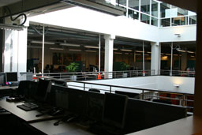
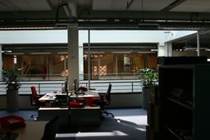
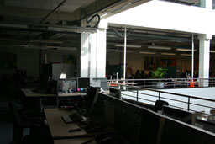
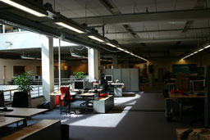

1979
Rotterdam, NL.

Studies
2003 – 2005
BA Fine Arts. AKI, Enschede, NL.

2001 – 2002
Digital design course. Danmarks Designskole, Copenhagen, DK.

September – December 2000
A variety of workshops dealing with object orientated programming. Danmarks Designskole, Copenhagen, DK.

1997 – 2001
Graphic design course. Royal Academy of Art (KABK), The Hague, NL.

Professional activities
2002
Research into an archiving system. Supervised by Netochka Nezvanova. Steim Institute, Amsterdam, NL.

2001 – 2002
Development of a prototype. The Museum of One Object. A proposal for a virtual museum. Kunstindustrie Museet (KIM), Copenhagen, DK.

Congresses/seminars/symposiums

2000
World@rt: exploring interactive expressions. (2 – 8 October). With Maurice Benayoun. Aalborg, DK: Aalborg University.

Lectures

2007
(Untitled). In: Opening week 2007. (8 – 12 January). Organized by Jan van Eyck Academie. ’s-Hertogen-bosch, NL: Verkadefabriek.

Discussions

2007
Material gathering. The unobstructed view. (2 July). With Jacqueline Schoemaker. Maastricht, NL: Jan van Eyck Academie.

Workshops
2003
Minor philosophy. (25 August – 31 December). With H.J. Achterhuis. Enschede, NL: University of Twente (UT).

2000
The public domain. Copenhagen, DK: Kunstakademiets Arkitektskole.
Concept development in digital art. (2 – 3 October). Aalborg, DK: Aalborg University.

Solo exhibitions
2007
Welfare on the move. In: Fahrt. (28 November 2007 – 7 January 2008). Maastricht, NL: Jan van Eyck Academie.

2006
De ruimte tussenin. Foto- en videosequenties. (12 March – 2 April). Utrecht, NL: Moira.

Group exhibitions
2005
(Untitled). In: Destillaat 8. (2 – 4 December). Nijmegen, NL: Extrapool.
(Untitled). In: Aanzet 2005. (12 November – 7 December). Diepenheim, NL: Kunstvereniging Diepenheim.
Overzichtstentoonstelling Eindexamens AKI 2005. (25 June – 3 July). Enschede, NL: AKI.
(Untitled). In: Kunstsommer 2005. (19 June – 24 July). Oberhausen, DE: Kunstverein Oberhausen.

2004
(Untitled). Enschede, NL: Concordia.
O sole mio. (24 – 25 January). Rheine, DE: Kloster Bentlage.

