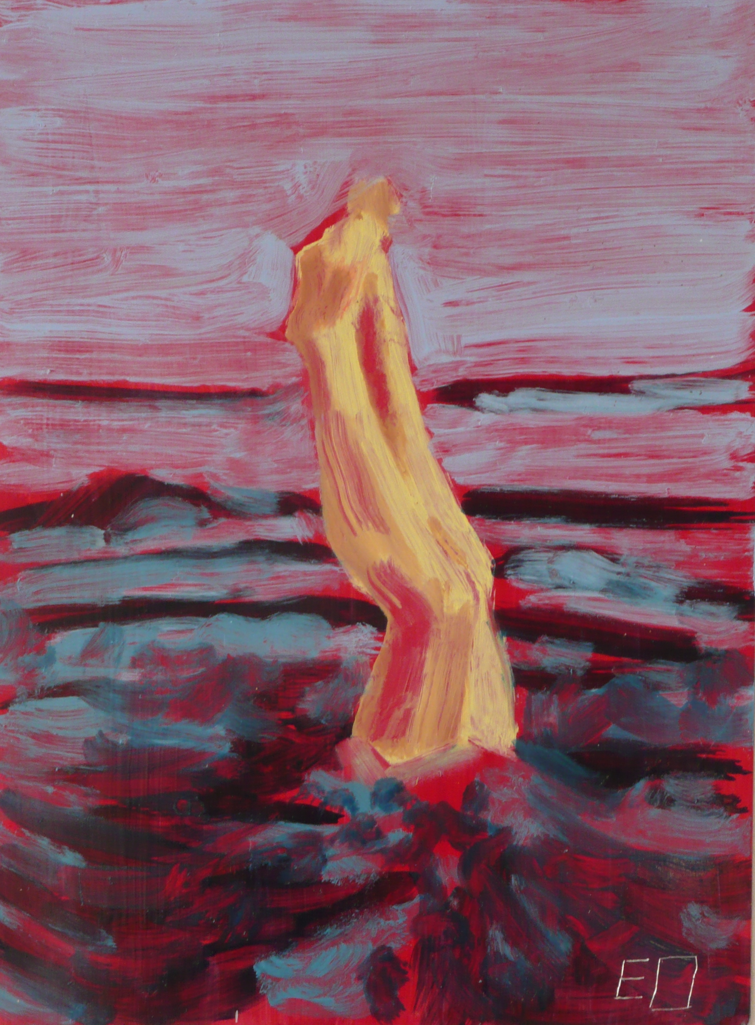

Erin O’Connor
30a Cephas Ave
London
E1 4AT
Tel: 079686224257
Email: erineoconnor@hotmail.com
www.erineoconnor.com

Biography

Born 1979, Cambridge, UK

BA (Hon) Fine Art Painting, Glasgow School of Art UK, 1998-2002

MA Fine Art Central Saint Martins 2007 -2008

Solo Shows

September 2007
Northern Rock Foundation Gallery, Erin O’Connor, Newcastle, UK

Group Shows

September 2008
Chinese Characters gallery, Private Practice, Budapest, Hungary

February 2008
Oxo Towers, Bargehouse, This Constant Cracking Surface, London, UK

November 2006
Cluny Gallery, The Octopus Tree, Newcastle, UK

April 2002
Vic Gallery, Katrina McEvoy and Erin O’Connor, Glasgow, UK

Awards

2006 Arts Council England, North East

Collections

Paintings in Hospitals Scotland
University of the Arts London

